PRESS RELEASE

FOR IMMEDIATE RELEASE

Eid al-Fitr Homecoming Traditions of ASEAN Communities

Kuala Lumpur, Kominfo Newsroom – Kuala Lumpur, Kominfo Newsroom - Going home to celebrate Eid al-Fitr with extended family is a tradition of Indonesian and Malaysian citizens as one ASEAN community.

Nur Yamsi Zakina, an Indonesian migrant worker in Johor Bahru, Malaysia, Wednesday, 19 April 2023, said that the homecoming tradition in Malaysia is more or less the same as in Indonesia. The goal is to gather and foster good relationships with the extended family in the hometown.

"In general, Malaysians will start returning to their hometowns two days before Eid," said Nur Yamsi Zakina, also known as Zaki.

In Eid 2022, Zaki, who worked part-time as a substitute household assistant, admitted that he also experienced homecoming with her employer from Johor Bahru to Melaka by land.

"It's jammed, Sis. The traffic jam is bad. Moreover, last year's Eid turned out to be earlier. I thought there were still two days left, but it turns out that the next day is Eid," she said.

In general, Malaysian's homecoming is the same as Indonesian. They would also bring various kinds of souvenirs for relatives in their hometowns. And usually, according to this migrant worker from East Java, they would bring special cakes made by themselves before going home.

Zaki admitted that she does not go home to Indonesia this year either. She plans to attend the Eid prayers at the Consulate General of the Republic of Indonesia in Johor Bahru. And the night before Eid, she will gather with other migrant worker friends there.

Meanwhile, an Indonesian citizen from West Sumatra, Wiffy Zalina Putri, who has lived in Malaysia since elementary school, said that Eid homecoming is customary for people in Malaysia. Married couples will take turns returning to their partner's hometown. "If this year to the husband's hometown, then the next year to the wife's," said Wiffy, also known as Fifi.

Mintarsih Warijan, another Indonesian citizen from East Java who has lived in Malaysia for decades, said she is going to her hometown to celebrate Eid with her extended family. She and her husband are already in Surabaya on Monday, 17 April, and will return to Kuala Lumpur near the end of the school holidays in early May.

A Malaysian resident, Ain Karim, always returns home to Perak after Eid al-Fitr prayers to avoid congestion on the road. "To my hometown, it takes an hour, so it's not too far," she said. She said traffic jams are very severe, especially the day before Eid. Because of that, she always chooses to return to her hometown on Eid Al-Fitr.

Meanwhile, another Malaysian, Hakimi Mohd Zain, would also do the tradition on D+1 Eid al-Fitr to his wife's hometown in Kuala Langsar, Perak. According to him, the crowds of Eid al-Fitr celebrations will be less pronounced in the city because all will return to their hometown.

Homecoming in Indonesia is the same tradition that people in Malaysia carry out. This common tradition can certainly become the glue that binds people together in the ASEAN region, as the center of world growth as the theme of the 2023 ASEAN Indonesia Chair, "ASEAN Matters: Epicentrum of Growth". (Virna/Elvira/TR)

***

Director General of Public Information and Communications of the Ministry of Communication and Informatics – Usman Kansong (0816785320).

Get more information at https://infopublik.id.

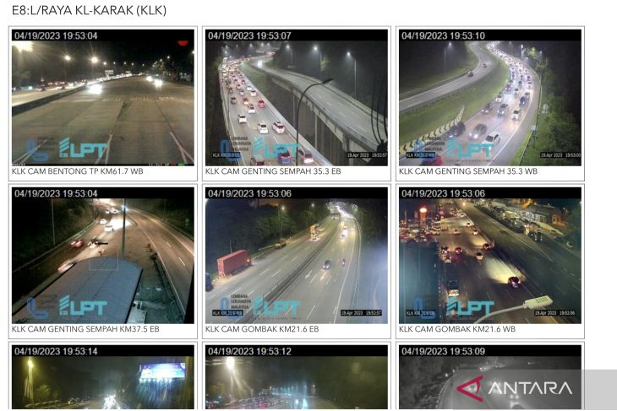

A screenshot of the CCTV monitor from the Lembaga Lebuhraya Malaysia shows traffic conditions on several sections of the KL-Karak toll road, Wednesday, 19 April 2023.

